Experiment 6 M. Devarajulu
Aim 192212058
To solve vacuum cleaner problem using python program
Algorithm
1 Start the program.
2 Initialize two rooms (A and B) with their status (Dirty or Clean).
3 Place the vacuum cleaner in Room A.
4 Check the current room:
- If the room is Dirty, clean it.
- If the room is Clean, do nothing.
5 Check whether both rooms are clean.
6 If both rooms are clean, stop the program.
7 Otherwise, move the vacuum cleaner to the other room.
8 Repeat the process until all rooms are clean.
9 Display the final status of both rooms.
10 End the program.
Program
# Vacuum Cleaner Problem

# Initial state of rooms
rooms = {
'A': 'Dirty',
'B': 'Dirty'
}

# Vacuum starts in Room A
location = 'A'

while True:
print("\nVacuum is in Room", location)

if rooms[location] == 'Dirty':
print("Room", location, "is Dirty -> Cleaning...")
rooms[location] = 'Clean'
else:
print("Room", location, "is already Clean.")

# Check if all rooms are clean
if rooms['A'] == 'Clean' and rooms['B'] == 'Clean':
print("\nAll rooms are clean.")
break

# Move to the other room
if location == 'A':
location = 'B'
else:
location = 'A'

print("\nFinal Room Status:")
print(rooms)

Output
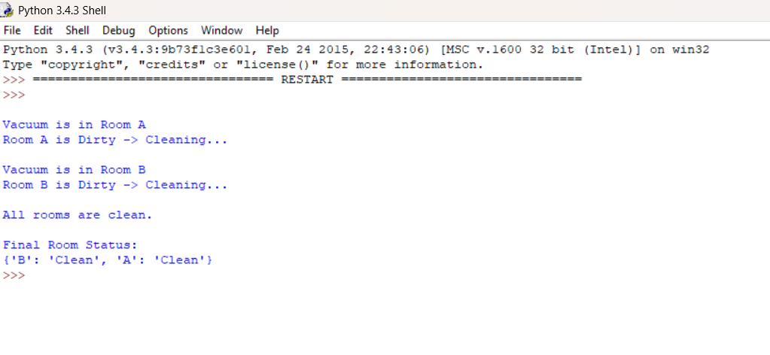

Result
• The vacuum cleaner starts in Room A.
• It cleans any dirty room it visits.
• It moves between Room A and Room B until both rooms are clean.
• Final State: {'A': 'Clean', 'B': 'Clean'}

